**Exercise 1: Configuring a Basic Spring Application**

**Scenario:** Your company is developing a web application for managing a library. You need to use the Spring Framework to handle the backend operations.

**Step 1: Set Up a Spring Project**

Add Spring Core Dependency in pom.xml

<dependencies>

<dependency>

<groupId>org.springframework</groupId>

<artifactId>spring-context</artifactId>

<version>5.3.33</version>

</dependency>

</dependencies>

**Step 2: Configure applicationContext.xml**

<?xml version="1.0" encoding="UTF-8"?>

<beans xmlns="http://www.springframework.org/schema/beans"

xmlns:xsi="http://www.w3.org/2001/XMLSchema-instance"

xsi:schemaLocation="

http://www.springframework.org/schema/beans

https://www.springframework.org/schema/beans/spring-beans.xsd">

<bean id="bookRepository" class="com.library.repository.BookRepository" />

<bean id="bookService" class="com.library.service.BookService">

<property name="bookRepository" ref="bookRepository" />

</bean>

</beans>

**Step 3: Define Service and Repository Classes**

**BookRepository.java**

package com.library.repository;

public class BookRepository {

public String getBookName() {

return "Spring in Action";

}

}

**BookService.java**

package com.library.service;

import com.library.repository.BookRepository;

public class BookService {

private BookRepository bookRepository;

// Setter for dependency injection

public void setBookRepository(BookRepository bookRepository) {

this.bookRepository = bookRepository;

}

public void printBookName() {

System.out.println("Book: " + bookRepository.getBookName());

}

}

**Step 4: Run the Application**

**MainApp.java**

package com.library;

import com.library.service.BookService;

import org.springframework.context.ApplicationContext;

import org.springframework.context.support.ClassPathXmlApplicationContext;

public class MainApp {

public static void main(String[] args) {

ApplicationContext context =

new ClassPathXmlApplicationContext("applicationContext.xml");

BookService service = (BookService) context.getBean("bookService");

service.printBookName();

}

}

**OUTPUT:**

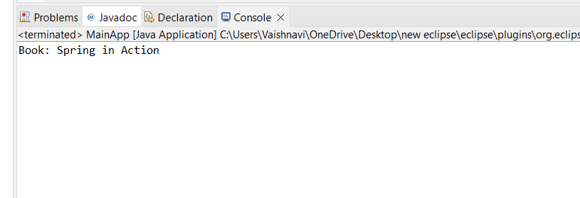

**Exercise 2: Implementing Dependency Injection**

**Scenario:**

In the library management application, you need to manage the dependencies between the BookService and BookRepository classes using Spring's IoC and DI.

**Step 1: Modify the XML Configuration**

**applicationContext.xml**

<?xml version="1.0" encoding="UTF-8"?>

<beans xmlns="http://www.springframework.org/schema/beans"

xmlns:xsi="http://www.w3.org/2001/XMLSchema-instance"

xsi:schemaLocation="http://www.springframework.org/schema/beans

http://www.springframework.org/schema/beans/spring-beans.xsd">

<bean id="bookRepository" class="com.library.repository.BookRepository" />

<bean id="bookService" class="com.library.service.BookService">

<property name="bookRepository" ref="bookRepository"/>

</bean>

</beans>

**Step 2: Update the BookService Class**

package com.library.service;

import com.library.repository.BookRepository;

public class BookService {

private BookRepository bookRepository;

public void setBookRepository(BookRepository bookRepository) {

this.bookRepository = bookRepository;

}

public void displayBooks() {

System.*out*.println(" List of Books:");

for (String book : bookRepository.getAllBooks()) {

System.*out*.println(" " + book);

}

}

}

**Step 3: Test the Configuration**

package com.library;

import com.library.service.BookService;

import org.springframework.context.ApplicationContext;

import org.springframework.context.support.ClassPathXmlApplicationContext;

public class MainApp {

public static void main(String[] args) {

// Step 1: Load Spring context from applicationContext.xml

ApplicationContext context = new ClassPathXmlApplicationContext("applicationContext.xml");

// Step 2: Get the bookService bean from the context

BookService bookService = (BookService) context.getBean("bookService");

// Step 3: Call the method to verify dependency injection worked

bookService.displayBooks();

}

}

**OUTPUT:**

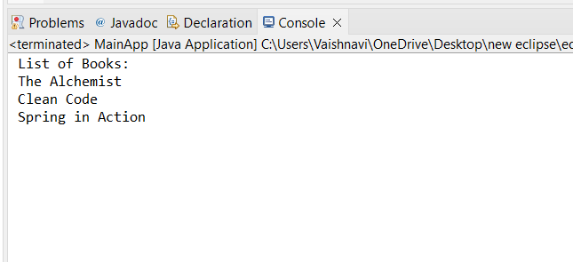

**Exercise 4: Creating and Configuring a Maven Project**

**Scenario:**

You need to set up a new Maven project for the library management application and add Spring dependencies.

**Add Spring Dependencies in pom.xml and Configure Maven Compiler Plugin**

<project xmlns="http://maven.apache.org/POM/4.0.0"

xmlns:xsi="http://www.w3.org/2001/XMLSchema-instance"

xsi:schemaLocation="http://maven.apache.org/POM/4.0.0

http://maven.apache.org/xsd/maven-4.0.0.xsd">

<modelVersion>4.0.0</modelVersion>

<groupId>com.library</groupId>

<artifactId>LibraryManagement</artifactId>

<version>1.0-SNAPSHOT</version>

<packaging>jar</packaging>

<dependencies>

<!-- Spring Context -->

<dependency>

<groupId>org.springframework</groupId>

<artifactId>spring-context</artifactId>

<version>5.3.31</version>

</dependency>

<!-- Spring AOP -->

<dependency>

<groupId>org.springframework</groupId>

<artifactId>spring-aop</artifactId>

<version>5.3.31</version>

</dependency>

<!-- Spring WebMVC (optional) -->

<dependency>

<groupId>org.springframework</groupId>

<artifactId>spring-webmvc</artifactId>

<version>5.3.31</version>

</dependency>

</dependencies>

<build>

<plugins>

<plugin>

<groupId>org.apache.maven.plugins</groupId>

<artifactId>maven-compiler-plugin</artifactId>

<version>3.8.1</version>

<configuration>

<source>1.8</source>

<target>1.8</target>

</configuration>

</plugin>

</plugins>

</build>

</project>

**OUTPUT:**

